2021 Geneva Forum – Rights of Nature Geneva Forum Presentation

From Earth Jurisprudence to the Whole Legal System:
Social Ecology and the Relational Approach to Law

Alex May

Hello everyone – sorry not to be able to join you in person, I was really hoping to but with Covid tests as well it ended up costing too much.

I’m Alex, I’m presenting you some thoughts which are part of my personal-research journey with Earth Jurisprudence. In short, I encountered Earth Jurisprudence near the end of my undergraduate law degree, and since then have been following the lead of ‘What about the rest of our legal systems?’.

More about me: www.alexmay.co.uk
More about my legal theory: www.interconnectedlaw.com
Note: my presentation is available online too, including expanded article: www.interconnectedlaw.com/Geneva2021

Main point of this presentation:

- We cannot transform only part of a (legal) system but must transform the whole system
- Earth Jurisprudence is only partial
- Therefore we need a broader approach for the entirety of our socio-ecological relations and activity

Most of this presentation will be about underlying conceptions, returning to law at the end. How we think about law depends on how we understand society, individuals, politics, etc.

Sidenote: I will talk about ‘Earth Jurisprudence’ instead of just ‘Rights of Nature’ because I see ‘Rights of Nature’ as just one part of Earth Jurisprudence and the broader transformation we need.

Earth Jurisprudence is about the relationship between humans and the rest of Nature, how that relationship has broken down deeply (spiritual, cultural) as well as in our political, economic, legal systems.

My initial thoughts around Earth Jurisprudence were: this is great, but what does it mean for other aspects of human activity?

I did some research about this, including about corporate law and human rights law. (as well as property law which much had been written about already)

Underlying Conceptions

I used to conceptualise it like this [top half of diagram 1]:
Of course, we are part of Nature, so it should be this [bottom half of diagram 1]:
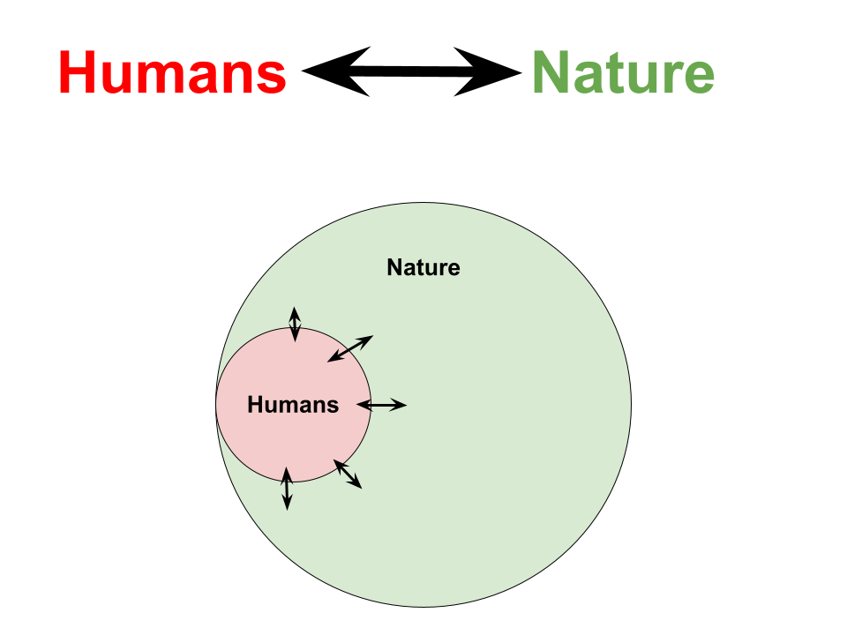

Understanding Humans

I was always interested in political theory and society aside from ecological things before integrating them. In that, I came across a few ideas which changed how I view things and how I conceptualise law.

(1) Individual and Society.

The liberal idea of the “island person” who is abstracted from others:

(see more: Capra and Luisi; Nedelsky Law’s Relations)

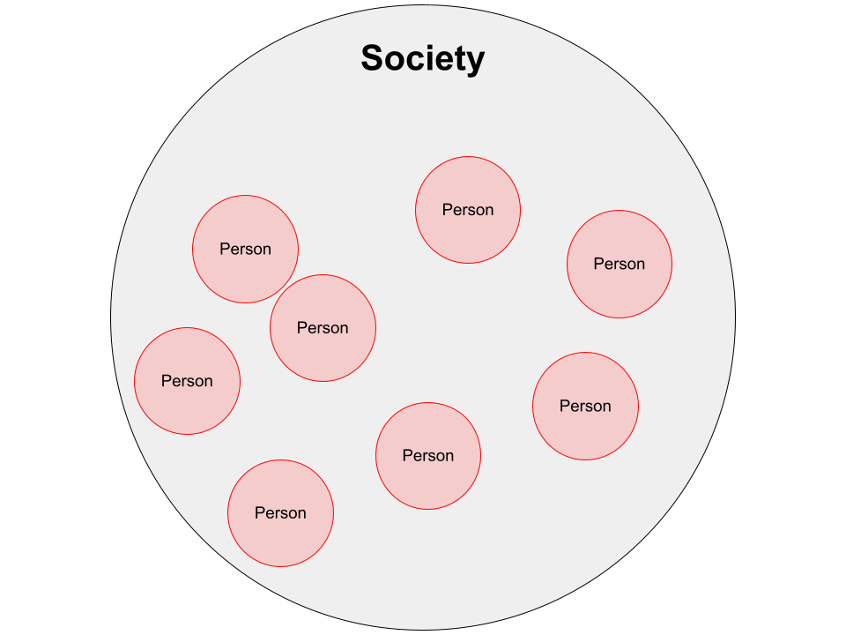

This is the atomised view of society: that society is simply an aggregation of individuals.

Primarily in this view, humans exist as individuals who sometimes interact with each other, and law governs these interactions to secure individual freedom.

The conclusion was:

We must understand humans and society as a web of social relations

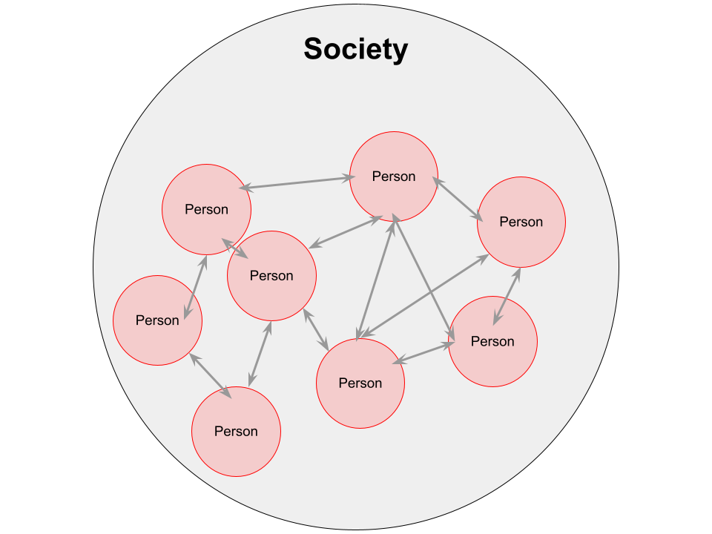

The individual is interconnected, embedded, not isolated. Humans are fundamentally social, our social relations matter at least as much as the “self”, we are constituted by our relations.

Yet this is just society without any ecological view… and we are interconnected not only with each other but with the rest of Nature...

Social Ecology

The key insights here are from Social Ecology (Murray Bookchin and many others).

The core point is:

Our ecological relationships and our social relationships cannot be separated.

Despite being simple and obvious once realised, this is not the general view. Instead of a division between relationships with other humans and with the rest of Nature, we have lots of socio-ecological relationships.

For example, ambient air quality is between everyone sharing a microclimate, driving cars in a city through to animals, plants, bacteria, fungi, etc. Environmental and social in one.

Because you can’t separate, the ecological crisis is a social crisis.

And ecological destruction is part of social domination between humans.

Therefore, addressing our ecological relationships must also include addressing social relationships.

Ultimately, we cannot only think about “Nature”. We must think about the human social systems which cause ecological harm and also are part of social oppression.

This is a big shift, we might want to just think about ‘conserving nature’, but we have to think about human social politics too. They are inseparable.

Which leads to this diagram:

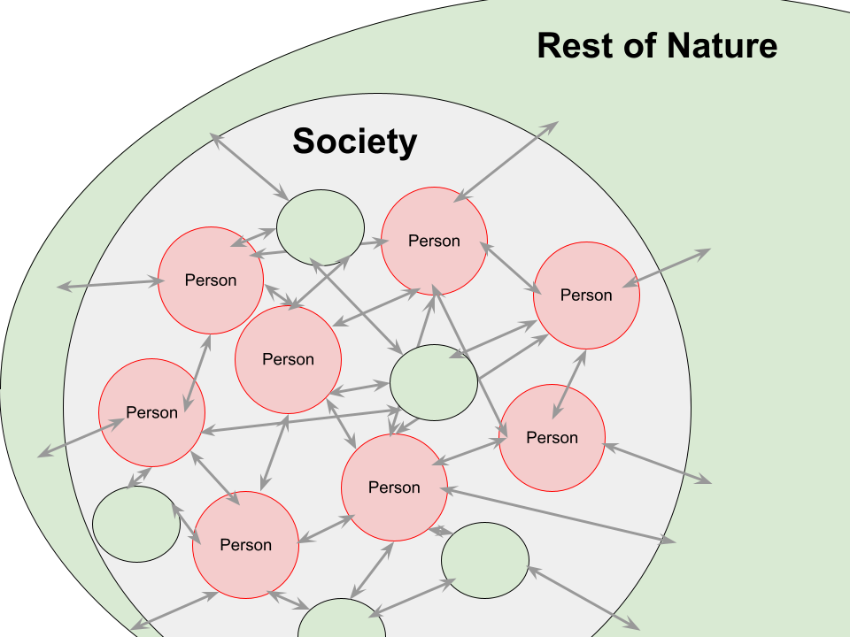
We see a web of social and ecological relationships.

Interconnected Law

My research project, which I’ve termed “Interconnected Law”, expanded from Earth Jurisprudence to be a holistic approach for law for our entirety of socio-ecological relationships.

It drew together these existing ideas I had come across:

- Earth Jurisprudence
- Social Ecology (discussed earlier)
- Systemic and Ecological Approaches
- Nedelsky’s Law’s Relations

Once we understand society as a web of socio-ecological relationships, we need an understanding of law which matches this.

The summary of the argument of Interconnected Law is:

- Humans are interconnected: not individual, but individuals in a dense network of socio-ecological relationships. See the forest and the trees (forests as relational!)

- Law should be based on this idea of humans, society and nature.

- Law is an important part of the web of relationships that exist, it influences, structures, etc, relationships.

- Law’s goal should be to improve the web of relations we live in so that they are better – more just, harmonious, empowering – so as to have a better society as part of a Whole Earth Community. Not how do we govern or command but how can we nurture, empower, protect, redirect.

Conclusion

I hope you found this a useful prompt, and I would love to talk further with anyone about these ideas.

This presentation and an expanded article is on my website: www.interconnectedlaw.com/Geneva2021

You can contact me alex@alexmay.co.uk.

