2021 Geneva Forum – Rights of Nature Geneva Forum Presentation

From Earth Jurisprudence to the Whole Legal System:
Social Ecology and the Relational Approach to Law

Alex May

Introduction

I’m Alex, I’m presenting some thoughts which are part of my personal-research journey with Earth Jurisprudence.

I was thinking about the Rights of Nature gathering and what part of my research would be best to share with others already interested in Earth Jurisprudence, and decided to share thoughts about how I’ve expanded from Earth Jurisprudence. This follows my personal research journey over the last few years.

I encountered Earth Jurisprudence near the end of my undergraduate law degree. I was exhausted and burned out after finishing my final exams, but I remembered seeing a few paragraphs from Cormac Cullinan’s book in my environmental law textbook, so I bought the book and read it a couple of months after the course. It was inspiring, connected with me deeply, and got me thinking about law again. I knew lots was wrong with our legal systems, and had studied some political and legal theory, but it was a wonderful vision of how things could be.

A year later I studied an LLM, and the main question driving me was: what should our legal system be like? I had looked into various areas of law and particular issues, but it seemed that the system as a whole needed changing. Earth Jurisprudence was good, but I was also thinking: ‘What about the rest of our legal systems?’. I did a research project for an NGO about corporate law which drew on some Earth Jurisprudence ideas, and in my LLM dissertation I looked at Earth Jurisprudence and Human Rights Law. In this, I came across the idea of the relational approach to law, more later.

Part of the conclusion of the dissertation was that Earth Jurisprudence and Human Rights Law could be conceptually and practically harmonised. It would need significant changes from current human rights, though progress is slowly in the right direction, but conceptually and structurally they are compatible. Politically, it was also clear the it isn’t possible to only do nature conservation without also dealing with the linked social issues.

Since then, I did a bit more reading, thinking, and writing, along this idea that there needs to be a conceptual framework for law which covers the whole system change. I called this ‘Interconnected Law’, because (1) I was integrating Earth Jurisprudence (“we are interconnected with Nature”) and the relational approach (“we are interconnected with each other”), and that word covered both, and (2) it had a nice positive emotional feel to it. In this presentation, I thought I would share a summary of my thoughts on why we must move beyond just Earth Jurisprudence.

More about me: www.alexmay.co.uk
More about my legal theory: www.interconnectedlaw.com

Summary of the Core Argument:

- We cannot transform only part of a (legal) system but must transform the whole system
- Earth Jurisprudence is only partial
- Therefore we need a broader approach for the entirety of our socio-ecological relations and activity

Most of my presentation and this article is about the underlying conceptions, returning to law at the end. How we think about law depends on how we understand society, individuals, politics, and so on. If we have the wrong understanding of humans, society and nature, or the wrong political framework, or the wrong values, then anything built on these will be mistaken.

Earth Jurisprudence is about the relationship between humans and the rest of Nature. It is both about how that relationship has broken down deeply spiritually and culturally, and about how our legal systems (as well as our political and economic systems) are flawed.

Sidenotes on Earth Jurisprudence

I’ve assumed the audience will have familiarity with it, but if you don’t, you could read a summary here: https://www.gaiafoundation.org/areas-of-work/earth-jurisprudence/ or a longer article I’ve written here: https://interconnectedlaw.com/rights-of-nature-and-earth-jurisprudence/.

Although it’s the ‘Rights of Nature’ Geneva Forum, I will talk about ‘Earth Jurisprudence’ instead of just ‘Rights of Nature’ because I see ‘Rights of Nature’ as just one part of Earth Jurisprudence.

Underlying Conceptions

So, I’ll start with the underlying conception of what we are looking at.

Earth Jurisprudence is about the relationship between humans and the rest of Nature. This might be seen like the arrow at the top of the diagram below, but really should be understood as a nested circle because humans are part of Nature:

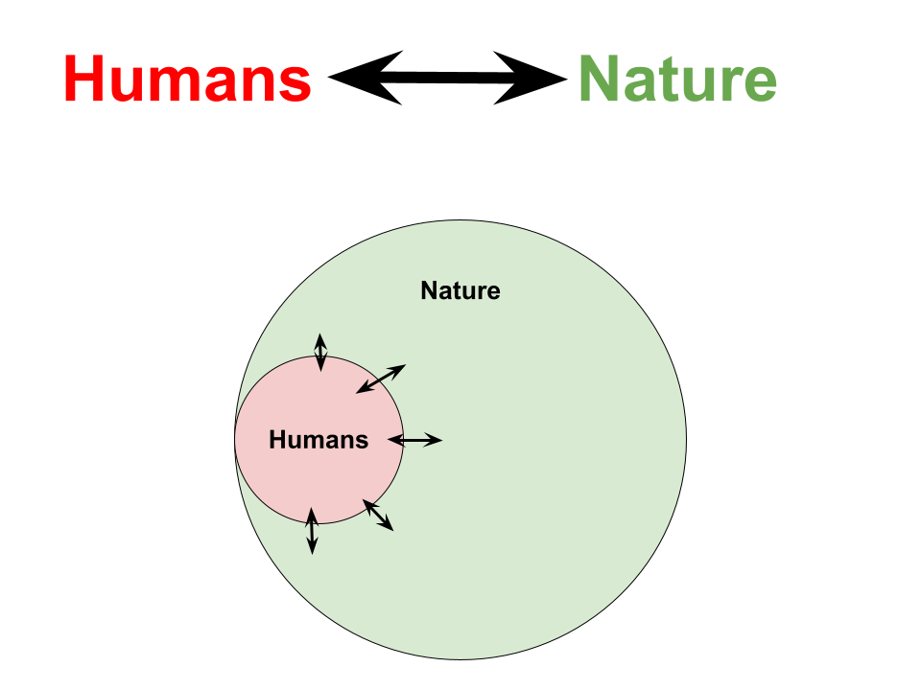
This is the model Earth Jurisprudence uses (I think!), with humans nested within the rest of Nature, looking at the relationship(s) between humans and the rest of Nature.

Humans and Society

As well as being interested in and researching environmental or ecological things, I have also long been interested in political theory and society. This section is influenced largely by Jennifer Nedelsky’s relational approach (Jennifer Nedelsky, Law’s Relations [Oxford University Press, 2011]) and Capra and Luisi’s Systems View (Fritjof Capra and Pier Liugi Luisi, The Systems View of Life [Cambridge University Press, 2014]).

The core idea is how we conceptualise the individual and society. This is a tension running throughout history, the individual versus the collective.

The traditional liberal (and neoliberal) idea is of the abstracted, atomised individual:

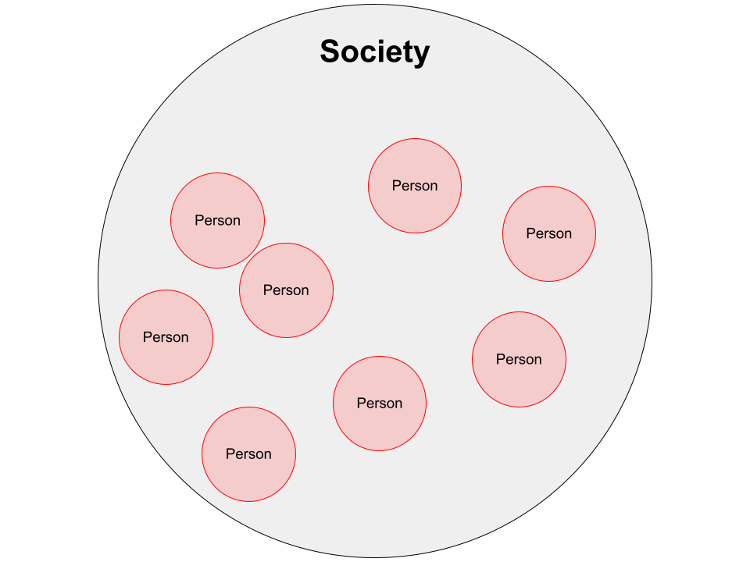

This is the atomised view of society: that society is simply an aggregation of individuals. Liberal philosophers like Locke and Hobbes developed an atomistic view of society, perhaps inspired by the development of the natural sciences during the scientific revolution. Capra and Luisi describe that ‘The worldview and value system that lie at the basis of the modern industrial age were formulated in their essential outlines in the sixteenth and seventeenth centuries.’ Society was reduced to the understanding of humans as primarily individual, which was then extrapolated to the state and societal level.

Primarily in this view, humans exist as individuals who sometimes interact with each other, and law governs these interactions to secure individual freedom.

Nedelsky’s relational approach to law challenges assumptions made in the dominant liberal approach to law. Instead of seeing humans as discrete, free-standing individuals, she argues that humans instead exist in a network of relationships, including social, economic and political relations.

In this approach we can see that humans need social relationships which support us and help us flourish, as well as economic relations which provide freedom, political empowerment and an environment which sustains life. Her work comes out of feminist legal scholarship, recognising the partiarchal nature of liberal conceptions of free-standing individuals with autonomy that needs protecting from outside interference, and the model of ownership as domination.

Nedelsky also shows how many liberal values – such as freedom, autonomy and security – are better understood in this relational context. For example, individual freedom requires ‘relations of freedom’ (Nedelsky, Law’s Relations p33). Nedelsky advocates both for ‘a shift in emphasis that moves relationship from the periphery to the centre of legal and political thought and practice’, but also ‘a gestalt-like change’ in understanding the world, and a paradigm shift in our legal political thought which follows this. She also recognises the parallels with her work and that of Earth Jurisprudence, though from an entirely different starting point.

In short, the conclusion is that we must understand humans and society as a web of social relations:

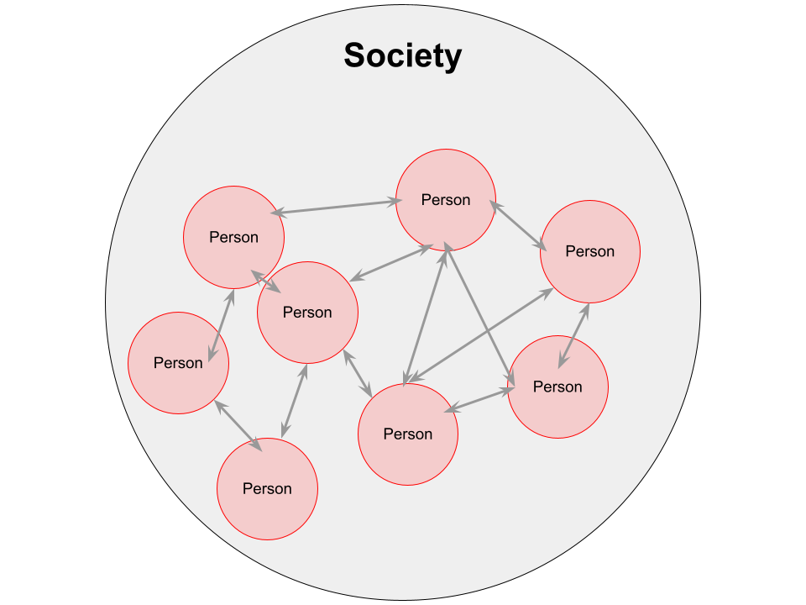

The individual is interconnected, embedded, not isolated. Humans are fundamentally social, our social relations matter at least as much as the “self”, we are constituted by our relations.

Yet this is just society without any ecological view… and we are interconnected not only with each other but with the rest of Nature… which brings us to:

Social Ecology

The key insights here are from Social Ecology (Murray Bookchin and many others).

The core point is:

Our ecological relationships and our social relationships cannot be separated.

Our mainstream view is to understand a division between “society” and “nature”, to distinguish between relationships with other humans and with the rest of Nature. Yet this is false; they are not separable. We live in a web of socio-ecological relationships.

To give one example, food production. Who grew the food – how much were they paid, were they an employee for a company and what were their working relations, what are the ecological impacts of the production, how did the food get to me, how did I get money for the food. Each food commodity which we purchase has a whole network of socio-ecological relations.

A second example is ambient air quality. This is commonly seen as an “environmental” issue, but it is clearly about socio-ecological relationships between humans (and, also, the local ecology). Everything sharing and participating in the localised climate is involved. Key causes are transport emissions, so actions of people drive cars or get a bus or cycle a bike. Who is most exposed, living on busy roads or on quieter residential streets with cleaner air, is about wealth, which of course intersects with many other social characteristics. And, presumably, there is also some involvement and effects on animals, plants, bacteria, fungi, etc.

And then, because there isn’t a separation between society and the rest of nature, or between social relations and ecological relations, it is the case that the ecological crisis is a social crisis.

In Murray Bookchin’s words:

“What literally defines social ecology as "social" is its recognition of the often overlooked fact that nearly all our present ecological problems arise from deep-seated social problems. Conversely, present ecological problems cannot be clearly understood, much less resolved, without resolutely dealing with problems within society. To make this point more concrete: economic, ethnic, cultural, and gender conflicts, among many others, lie at the core of the most serious ecological dislocations we face today – apart, to be sure, from those that are produced by natural catastrophes.”

Quote from: What is Social Ecology? By Murray Bookchin, From Social Ecology and Communalism, AK Press, first printing, 2007. PDF available online such as here.

In other words, ecological destruction is part of social domination between humans. Which means that addressing our ecological relationships must also include addressing social relationships.

Ultimately, we cannot only think about “Nature”. We must think about the human social systems which cause ecological harm and also are part of social oppression. Environmental politics does not make sense, and cannot be seriously effective in transforming the relationships between humans and the rest of Nature, if it is not also involving social political issues.

This is a big shift, and may be intimidating for many who just want to think about ‘conserving nature’ and ‘green politics’, but this is the reality we face.

To bring it back to the diagrams I have been using to conceptualise things, here is the final one:

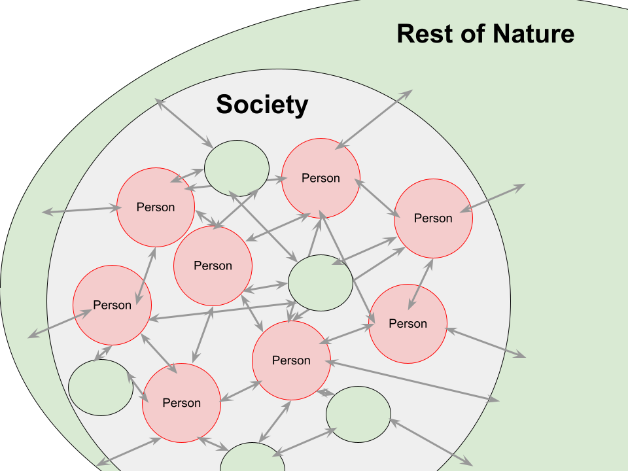
This symbolises a web of social and ecological relationships.

Interconnected Law

My research project, which I’ve termed “Interconnected Law”, expanded from Earth Jurisprudence to be a holistic approach for law for our entirety of socio-ecological relationships.

It drew together these existing ideas I had come across:

- Earth Jurisprudence
- Social Ecology (discussed earlier)
- Systemic and Ecological Approaches
- Nedelsky’s Law’s Relations

Once we understand society as a web of socio-ecological relationships, we need an understanding of law which matches this.

The summary of the argument of Interconnected Law is:

- Humans are interconnected: not individual, but individuals in a dense network of socio-ecological relationships. See the forest and the trees (forests as relational!)

- Law should be based on this idea of humans, society and nature.

- Law is an important part of the web of relationships that exist, it influences, structures, etc, relationships.

- Law’s goal should be to improve the web of relations we live in so that they are better – more just, harmonious, empowering – so as to have a better society as part of a Whole Earth Community. Not how do we govern or command but how can we nurture, empower, protect, redirect.

If you would like to read more about my ideas of Interconnected Law, there is more on the website, www.interconnectedlaw.com. There are various articles on the blog, or my most in-depth presentation of the ideas can be found in this presentation (available either in audio format or as a downloadable article, which includes a “summary” as well as a detailed presentation).

Conclusion

I hope you found the ideas made here about expanding from Earth Jurisprudence interesting and the argument compelling.

If anybody would like to talk further about these ideas, you can contact me alex@alexmay.co.uk.

